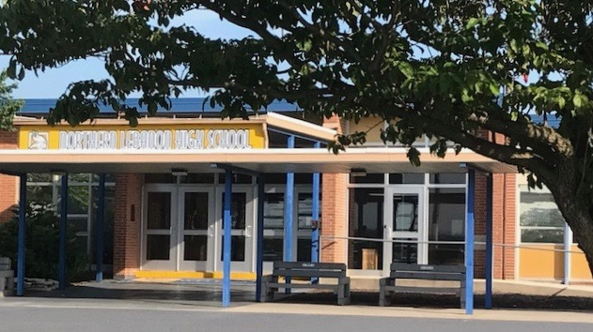

NLSD 2020-2021

Reopening plan

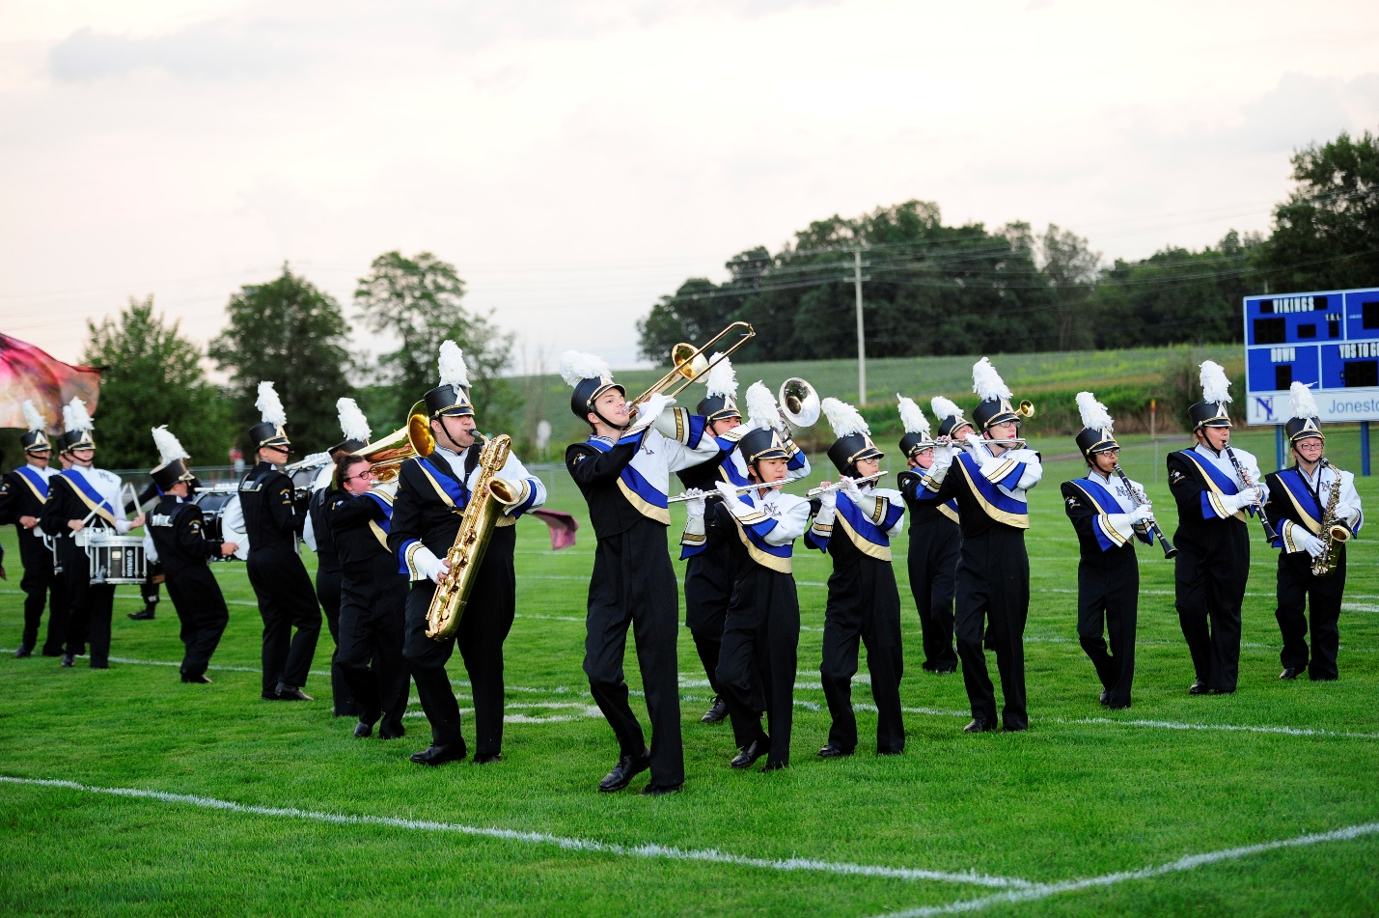
Reopening Plan Framework

Throughout the summer the Northern Lebanon School District (NLSD) drafted an initial framework for the school reopening plan. The framework included scenarios that created options for parents/students aligned to Governor Wolf’s Process to Reopen Pennsylvania pandemic color scale of red, yellow and green phases. The NLSD Instructional Plan and the Health and Safety Plan utilize different terminology when talking about levels. The Instructional Plan refers to the different options as Level I, Level II, and Level III. In the Green phase, any of the Instructional Plan levels could be used. In the Yellow phase, Level II or Level III could be used. In Red, Level III would be used. NLSD understands that there is no perfect way to decide which level to return and continue school. The superintendent will monitor local cases and will communicate with the School Board when metrics indicate a possible change in level.

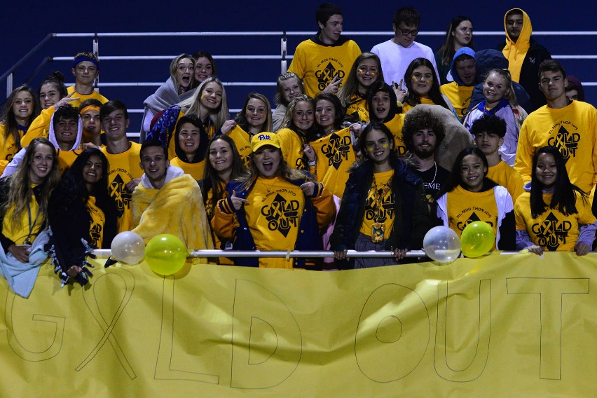

Instructional Plan Summary

At all 3 levels students will be able to livestream classes from home or enroll in our V3 academy.
LEVEL I – Fully Return to School
- District students attend school Monday through Friday.
- Students have the option to view classes virtually from home.
- Continue to follow applicable CDC, DOH, and PDE guidelines.
LEVEL II – Hybrid Learning Model
Elementary: All students will be able to choose between physically attending school or virtually their classes from home.

Secondary:
- Approximately 50% of District students physically attend Monday/Thursday or Tuesday/Friday.
- On days that students are not attending physically, attendance will be determined by attendance at the live-streamed class or work completion.
- Wednesdays, students will work remotely from home. Staff will work to support students from classrooms/offices.
- Students will be assigned to either Group A, Group B, or Group C and this will be communicated to families in mid-August.

LEVEL III – Fully Virtual
- Schools will be closed for in-person instruction and all instruction must be provided virtually. If schools are allowed to bring a limited number of students to buildings the following plan may be utilized for the elementary level upon approval by the Northern Lebanon School Board.
- Elementary students will be divided into two groups. One group will attend in-person during the morning for reading and math instruction. A second group will virtually attend in the morning for specials, science, and/or social studies instruction. The groups will then have the opposite schedule in the afternoon.
- Schedule will be modified for students but daily work will be required.

Health and Safety Plan Summary

As of the drafting of this plan, Lebanon County is in the Green Phase of Governor Wolf’s Process to Reopen Pennsylvania. In order to provide maximum flexibility for NLSD to adjust between different phases, this plan has been developed in alignment with the requirements outlined by the Pennsylvania Department of Education in the Green Phase but maintains many of the protocols that are outlined in the yellow phase.

School Infection Control and Mitigation Guidelines

PDE plan requirements addressed in this section include:

● Restricting the use of cafeterias and other congregate settings, and serving meals in alternate settings such as classrooms
● Staggering the use of communal spaces and hallways
● Reducing the number of individuals in classrooms and other learning spaces, and interactions between groups of students
● Strategic deployment of staff
● Hygiene practices for students and staff including the manner and frequency of hand washing and other best practices
● Use of face coverings (masks or face shields) by all staff
● Use of face coverings (masks or face shields) by students
● Limiting the sharing of materials among students

Information on face coverings: All district staff will be required to wear face coverings (either a face mask or face shields). For students, the district will follow the Governor’s Executive Order on face coverings. All students of all levels will be required to wear face coverings at school and on school busses, regardless of their grade level. Exemptions will be made in accordance with the Governor’s Executive Order or as otherwise required by law. Students will need to provide documentation to be exempted from this order.

Classroom Recommendations

- Classroom Layout: PDE allows for a shorter distance than six feet between desks if six (6) feet is not achievable in classrooms. Classroom configurations should be altered for the greatest amount of social distancing possible. For example: Staggered rows of desks all facing the same direction, arrangement of desks in a U shape, with limitations on face-to-face seating. In classrooms with round desks, teachers should create a seating chart.

- Desk Cleaning: Students at all levels, when developmentally appropriate will wipe their desks and/or equipment prior to leaving the space. Students arriving at a desk and/or equipment will have the option to wipe it down with disinfecting wipes or other cleaning supplies.

Cafeteria Recommendations

- Assigned Seating: All buildings will establish additional seating areas in order to obtain the greatest amount of social distancing possible.
- Cashier: Plexiglass barrier will be available at the checkout area and cash transactions will be discouraged in lieu virtual payments using the student’s ID that they swipe.
- Cleaning Supplies: The district’s food service providers will ensure the most effective and safe products to sanitize tables and other areas are available.
- Hand Washing: Individuals will be reminded to sanitize or wash their hands prior to and after eating.
- Lunch Lines: Buildings will encourage social distancing when in queue lines and ask individuals to remain seated as much as possible when in the cafeteria.
- Scheduling: Schedules will be developed to create small groups and to minimize cross grouping.

Arrival and Dismissal Recommendations

Traditional transportation schedules will continue to be provided daily to all students with updated procedures in place for the possibility of an increase in student drop-off and pick-up if parents choose not to access District transportation. Building specific drop off and pick up procedures will be developed and communicated to parents.

- Traditional daily transportation schedules will continue to be provided to all students. Masks will be mandatory while on the bus, as social distancing will not be possible.
- Parents will be provided the option to drive their child to and from school each day.
- Procedures will be established if necessary, to accommodate an increased number of car riders at each building.
- Each building will establish arrival and dismissal procedures/schedule to allow for social distancing

Shared and Classroom Materials Recommendations

- Buildings will create procedures to limit the sharing of materials among students
- Online textbooks and novels should be used if possible
- Library books will be placed in quarantine when returned to the library before returning to circulation
- Student's belongings should be separated from others' and in individually labeled containers, cubbies, lockers, or other areas. Having adequate supplies will minimize sharing of high-touch materials to the extent possible.
- Cleaning procedures or item quarantine procedures will be put in place for items such as iPads, chromebooks, utensils, books, classroom libraries, manipulatives, science kit materials, special area items, and toys.
- Students and staff will be encouraged to use individual water bottles from home or disposable plastic bottles.

Office Recommendations

- Buildings will develop and post visitor procedures to ensure social distancing expectations
- All district staff will be required to wear face coverings (either a face mask or face shield) at all times. For visitors, the district will follow the Governor’s Executive Order on face coverings. Building leaders should ensure that masks are available for individuals that do not have access prior to entering the building. Exemptions will be made in accordance with the Governor’s Executive Order or as otherwise required by law.
- Front office areas will have plexiglass barriers installed as an additional precaution.
- Special attention will be paid to areas where people may form lines or congregate. Areas will be marked off designating waiting areas (chairs, etc.)
- Staff should wash or sanitize their hands frequently and before and after touching shared items and before and after eating.

Student Health Plan

Monitoring Student Health

- Parents/guardians will be asked to monitor their children’s temperature and any symptoms of illness on a daily basis.
- Symptom screenings to include temperature checks will be completed at home by parent(s)/guardian(s) before school on a daily basis.

Responding to an Infected Student
- Students who are ill or demonstrating signs/symptoms during the school day will be sent to the nurse’s office and the health services protocol will be followed to provide care for the student.
- If it is known that any student within a school community becomes ill or has been exposed to an individual confirmed positive for COVID-19, they will be immediately isolated and/or sent home and required to quarantine as appropriate.
- Students with symptoms of communicable disease will be isolated to the extent possible and excluded from school in accordance with the PA Department of Health guidelines.

Returning an Infected Student to School
- Conditions in which a student or staff member can return to school/work will be established through consultation with the School Physician, local health care professionals, and state or federal guidelines.
- Students who were displaying symptoms may return to school with a clearance note from a health care provider OR after at least ten (10) days have passed since symptoms first appeared which includes being fever free for at least 24 hours without fever-reducing medication.
- Students should be seen by a school nurse upon return to school.

Protecting Vulnerable Students

- Students deemed medically fragile will have an appropriate team meeting, IEP meeting, or 504 team meeting to determine appropriate supports and services prior to their return to school.
- Accommodations will be made in accordance with district policy and PA Department of Education guidelines, for any student or staff who has written documentation regarding the need for accommodations related to COVID-19.

Staff Health Plan

Monitoring Staff Health

- Prior to coming into work every day, all staff will need to complete a symptom screening.
- Employees are encouraged to self-report any symptoms to their supervising administrator

Responding to an Infected Staff Member

A variety of leave options are available to employees including: Families First Coronavirus Response Act (FFCRA), Family Medical Leave Act (FMLA), paid illness leave, and optional leaves of absences. Employees are encouraged to discuss their leave options with the Business Manager. Employees will receive education on steps to take to minimize risk.

Steps that should be taken in response to an infected staff member:
- Send the employee home immediately, if they become sick during the work day
- Ensure that the building leader is aware of the probable or confirmed case
- Close off any area visited by the employee who is a probable or confirmed case of COVID-19 for a minimum of twenty-four (24) hours prior to cleaning. Windows and doors should be opened when possible.
- Identify employees and students who were in close contact, defined as within six (6) feet for more than fifteen (15) minutes, with the person who is a probable or confirmed case of COVID-19 from a period of forty-eight (48) hours before symptoms to the time they were isolated.
- Building leader should contact the Office of the Superintendent.
- Building leader should contact the Director of Buildings and Grounds with the following information:
  - Buildings visited
  - Rooms visited
  - Timeline of the onset of symptoms, starting 48 hours prior to onset of symptoms

Returning and Infected Staff Member to Work

An infected staff member may return to work when the following criteria are met:

- At least one (1) day (24 hours) has passed since recovery defined as resolution of fever without the use of fever-reducing medications and improvement in respiratory symptoms (e.g., cough, shortness of breath);
- At least ten (10) days have passed since symptoms first appeared;

Protecting Vulnerable Staff Members

- Staff will be expected to attend work in accordance with up-to-date attendance guidelines and policies. Qualified disabilities covered under the American Disabilities Act (ADA) will be reviewed. Employees may be eligible for leave according to FMLA, FFCRA, or district leave policies.
- Accommodations will be made in accordance with district policy and PDE guidelines, for any student or staff who has written documentation regarding the need for accommodations related to COVID-19.

Operations-
Space Utilization Plan
PDE plan requirements addressed in this section include:

All classrooms and learning spaces throughout the District will be evaluated and reorganized, to the maximum extent feasible, to provide students and staff with the maximum social distancing to mitigate the spread of COVID-19. Building schedules and routines (student movement within a building, change of classes, recess, lunch schedules, etc.) will be assessed to minimize contact between individuals throughout the school day.

- All District classrooms/learning spaces will be evaluated based on the number of students assigned to each location.
- Classrooms/learning spaces will be redesigned as appropriate to ensure to the maximum extent feasible social distancing among students and staff throughout the day.
- Group learning spaces will be minimized or removed to provide additional space if needed for social distancing.
- Learning areas used for academic support will also be evaluated based on the number of students assigned and redesigned to the extent feasible to ensure separation of students and staff.

The use of communal spaces will be evaluated, and safe and appropriate usage will be communicated based on the current color stage of the county. Staff will be encouraged to utilize outdoor space for learning activities when possible and appropriate for increased engagement as well as social distancing. Playground schedules will be evaluated to minimize the number of students outside at one time and activities will be assessed to minimize student contact.

All social distancing and safety protocols will be evaluated at each building and will be designed to appropriately meet the age group of the students in attendance. All staff and students will be provided training on social distancing and other safety protocols.

Training will be provided through the most effective process available at the time (online, small group, individual, etc.) Parents and the community will be made aware of these protocols. Safety protocols will be continuously evaluated by staff to ensure fidelity of implementation.

Custodial Service Plan
PDE plan requirements addressed in this section include:
● Cleaning, sanitizing, disinfecting, and ventilating learning spaces, surfaces, and any other areas used by students (i.e., restrooms, hallways, and transportation)
● Restricting the use of cafeterias and other congregate settings, and serving meals in alternate settings such as classrooms
● Staggering the use of communal spaces and hallways
● Limiting the number of individuals in classrooms and other learning spaces, and interactions between groups of students
● Strategic deployment of staff
● Limiting the number of individuals in classrooms and other learning spaces, and interactions between groups of students

The main focus of this plan is to provide the highest level of disinfecting/sanitizing of high touch areas throughout each school building every day classes are in session, given the limited custodial staff in each building. High-touch areas include but are not limited to: door knobs, panic bars, handrails, counters, desk tops, chairs, computer equipment, pens used for visitor or student sign in, restroom fixtures, drinking fountains, and food service lines.

Assistance from cafeteria staff, building assistants, hall monitors, other support staff, as well as building leadership is required to keep the buildings disinfected/sanitized to the extent practical and possible throughout the day.

Additional support from the Director of Buildings and Grounds will keep building custodians focused on cleaning/disinfecting and sanitizing by having the custodial staff log the cleaning/disinfecting and sanitizing they do daily. The Director of Buildings and Grounds will also assume responsibility for minor maintenance items such as light bulbs, filters, etc.

After dismissal for the day: The entire building will undergo a typical top to bottom cleaning with an emphasis on disinfecting/sanitizing of high touch areas:
a. All buildings will be cleaned with an approved sanitizing cleaner.
b. Outside air dampers in occupied areas of the building will be opened to a maximum level to bring in fresh air while still being able maintain a comfortable temperature. Weather conditions will be a factor.
c. Classrooms will be systematically treated using an electrostatic sprayer.
d. Classrooms will be systematically cleaned daily with a sanitizer.
e. Hallways, restrooms, main and guidance offices will be treated with an electrostatic sprayer when feasible.
f. Hallways, restrooms, main and guidance offices will be systematically cleaned daily with a sanitizer.
g. Water fountains will be turned off.
h. Partitions will be installed between urinals and sinks.
i. Hand sanitizer will be available in all instructional spaces, common areas, and office areas.
j. Transportation (buses and vans) will be disinfected/sanitized between all AM and PM runs.

More frequent restroom checks, ensuring an adequate supply of soap will also be a priority throughout the day.

Adequate supplies have been procured and will be distributed to all buildings. These include:
1. Sanitizing Wipes
2. Ready to Use Disinfectant/Sanitizer
3. Spray Bottles for Disinfectant/Sanitizer
4. Hand Sanitizer
5. Face Masks/Face Shields

The Director of Buildings and Grounds also procured sheets of polycarbonate materials and is fabricating social distancing barriers for all reception areas.

Food Service Plan
All students will be offered breakfast and lunch within our buildings, in the same fashion as a typical school day, on the days they attend class in a district building.
- Within the Green and Yellow Phase, cafeterias and other congregate settings may be used to the extent possible.
- District cafeterias and other congregate settings will be evaluated and scheduled based on student numbers that can provide appropriate social distancing to the extent possible.
- New seating plans will be developed to ensure appropriate student/staff distancing.
- Schedules will be evaluated to alleviate multiple groups of students/staff from moving through cafeteria food lines at the same time.
- Schedules will be evaluated to alleviate multiple groups of students entering and exiting cafeterias and other congregate spaces at the same time.
- A reduced number of food options will be provided as well as opportunities for condiments and other items that would require additional student movement.

Transportation Plan
PDE plan requirements addressed in this section include:

● Adjusting transportation schedules and practices to create social distance between students

NLSD and DB Fisher Transportation will work together to provide:
- Efficient schedules that will provide safe and timely transportation to and from all buildings in accordance with the adopted reopening attendance schedule
- Letters will be sent to all parents informing them of the inability to provide adequate numbers of buses for social distancing and the need for their children to wear face coverings
- Masks and hand sanitizer will be available on buses for all public and private school students boarding
- Buses will be sanitized twice daily.

Visitor and Volunteer Management Plan
PDE plan requirements addressed in this section include:
● Identifying and restricting non-essential visitors and volunteers

NLSD will limit non-essential visitors to each of our buildings to mitigate the spread of COVID-19. NLSD will restrict the use of school buildings by outside organizations deemed to be non-essential. Non-essential persons, to include guest speakers and presenters, volunteers, and visitors, will be restricted from entering district buildings. Entry points and exit points will be established for each building, controlling the flow of traffic.

Where practical, the district will limit in person meetings, such as for IEPs, parent/teacher conferences, and staff meetings. Use of teleconferencing or video conferencing will be used to the greatest extent possible.

Communications
Pre-entry Communications Plan
PDE plan requirements addressed in this section include:
● Posting signs, in highly visible locations, that promote everyday protective measures, and how to stop the spread of germs)

The goal of the Pre-Entry Communication Plan is to communicate all new protocols to reduce transmission of the disease before students and staff enter school buildings. In order to ensure effective communication of information related to new protocols, the district will communicate with students, staff, parents, and community members in a variety of ways.

Throughout the summer, the NLSD Administrative Team will send relevant newsletter emails to staff and send relevant email blasts to community members and families. The Administrative will support the announcement of this reopening plan on August 4, including releasing relevant information to the media via a press release, web news story, and social media.To best prepare students, staff, and families for the start of school, the Administrative Team will send emails to all district families, providing an overview of the communications tools that will be used to provide information on the reopening plan. In order to ensure that all families receive this information, a robocall/text will be sent to supplement the communications overview email.

In addition to posting this plan on the district website, the Administrative Team will develop a reopening plan section of the district website, including FAQs. This will enable the district to add additional detail to the plan as the district moves into the training and implementation phase.

Post Entry Communications Plan
PDE plan requirements addressed in this section include:
● Notifying staff, families, and the public of school closures and within school year changes in safety protocols

The goal of the Post-Entry Communication Plan is to continually reinforce safety protocols and to ensure that staff, families, and the public are notified of school closures and within school year changes in safety protocols. NLSD will utilize a number of communication tools to notify staff, families and the public of a school closure including, but not limited to: the District webpage, School Messenger (phone, text, and e-mail messaging), social media, and letters.

Training Plan
PDE plan requirements addressed in this section include:
● Schedules for training all faculty and staff on the implementation of the Health and Safety Plans before providing services to students

Upon approval of this plan by the NLSD School Board, a comprehensive training module will be developed by a group of Administrative Team members and will be customized for use by buildings and departments. Staff will receive training the week prior to students returning to buildings. To the greatest extent possible, the training will be delivered online to ensure compliance with the School Infection Control & Mitigation Guidelines outlined above.

